**Garbage collection**

* But in Java, the programmer need not to care for all those objects which are no longer in use. Garbage collector destroys these objects.
* Garbage collector is best example of [Daemon thread](https://www.geeksforgeeks.org/daemon-thread-java/) as it is always running in background.
* Main objective of Garbage Collector is to free heap memory by destroying **unreachable objects**.

Unreachable objects: An object is said to be unreachable if it doesn’t contain any reference to it. Also note that objects which are part of island of isolation are also unreachable.

Integer i = new Integer (4);

// the new Integer object is reachable via the reference in 'i'

i = null;

// the Integer object is no longer reachable.

Garbage collection

Eligibility for garbage collection: An object is said to be eligible for GC (garbage collection) if it is unreachable. In above image, after i = null; integer object 4 in heap area is eligible for garbage collection.

1. 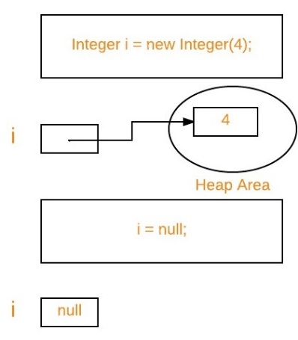
2. **Eligibility for garbage collection:**An object is said to be eligible for GC (garbage collection) if it is unreachable. In above image, after *i = null;* integer object 4 in heap area is eligible for garbage collection.

**Ways to make an object eligible for GC**

* Even though programmer is not responsible to destroy useless objects but it is highly recommended to make an object unreachable (thus eligible for GC) if it is no longer required.
* There are generally four different ways to make an object eligible for garbage collection.
  + 1. Nullifying the reference variable
    2. Re-assigning the reference variable
    3. Object created inside method
    4. [Island of Isolation](https://www.geeksforgeeks.org/island-of-isolation-in-java/)
* Object 1 references Object 2 and Object 2 references Object 1. Neither Object 1 nor Object 2 is referenced by any other object. That’s an island of isolation.
* Basically, an island of isolation is a group of objects that reference each other but they are not referenced by any active object in the application. Strictly speaking, even a single unreferenced object is an island of isolation too.

|  |
| --- |
| public class Test  {      Test i;      public static void main(String[] args)      {          Test t1 = new Test();          Test t2 = new Test();            // Object of t1 gets a copy of t2          t1.i = t2;            // Object of t2 gets a copy of t1          t2.i = t1;            // Till now no object eligible          // for garbage collection          t1 = null;            //now two objects are eligible for          // garbage collection          t2 = null;            // calling garbage collector          System.gc();        }        @Override      protected void finalize() throws Throwable      {          System.out.println("Finalize method called");      }  } |

Run on IDE

Output:

Finalize method called

Finalize method called

**Ways for requesting**[**JVM**](https://www.geeksforgeeks.org/jvm-works-jvm-architecture/)**to run Garbage Collector**

* Once we made object eligible for garbage collection, it may not destroy immediately by garbage collector. Whenever JVM runs Garbage Collector program, then only object will be destroyed. But when JVM runs Garbage Collector, we cannot expect.
* We can also request JVM to run Garbage Collector. There are two ways to do it :
  + 1. **Using *System.gc()* method** : System class contain static method *gc()* for requesting JVM to run Garbage Collector.
    2. **Using *Runtime.getRuntime().gc()* method** : [Runtime class](https://www.geeksforgeeks.org/java-lang-runtime-class-in-java/) allows the application to interface with the JVM in which the application is running. Hence by using its gc() method, we can request JVM to run Garbage Collector.

|  |
| --- |
| // Java program to demonstrate requesting  // JVM to run Garbage Collector  public class Test  {      public static void main(String[] args) throws InterruptedException      {          Test t1 = new Test();          Test t2 = new Test();            // Nullifying the reference variable          t1 = null;            // requesting JVM for running Garbage Collector          System.gc();            // Nullifying the reference variable          t2 = null;            // requesting JVM for running Garbage Collector          Runtime.getRuntime().gc();        }        @Override      // finalize method is called on object once      // before garbage collecting it      protected void finalize() throws Throwable      {          System.out.println("Garbage collector called");          System.out.println("Object garbage collected : " + this);      }  } |

* Run on IDE
* Output:
* Garbage collector called
* Object garbage collected : Test@46d08f12
* Garbage collector called
* Object garbage collected : Test@481779b8
* **Note :**
  + 1. There is no guarantee that any one of above two methods will definitely run Garbage Collector.
    2. The call System.gc() is effectively equivalent to the call : Runtime.getRuntime().gc()

**Finalization**

* Just before destroying an object, Garbage Collector calls finalize() method on the object to perform cleanup activities. Once finalize() method completes, Garbage Collector destroys that object.
* finalize() method is present in [Object class](https://www.geeksforgeeks.org/object-class-in-java/) with following prototype.
* protected void finalize() throws Throwable

Based on our requirement, we can override finalize() method for perform our cleanup activities like closing connection from database.

**Note :**

* 1. The finalize() method called by Garbage Collector not [JVM](https://www.geeksforgeeks.org/jvm-works-jvm-architecture/). Although Garbage Collector is one of the module of JVM.
  2. [Object class](https://www.geeksforgeeks.org/object-class-in-java/) finalize() method has empty implementation, thus it is recommended to override finalize() method to dispose of system resources or to perform other cleanup.
  3. The finalize() method is never invoked more than once for any given object.
  4. If an uncaught exception is thrown by the finalize() method, the exception is ignored and finalization of that object terminates.